DSBA6211 Spring 2026 - Assignment 05
Credit Card Default Survival Analysis

Dataset: default-of-credit-card data
A major financial institution wants to improve its credit card risk management by analyzing the time-to-default patterns using historical credit card data from Taiwan. Using survival analysis techniques, you will help develop a predictive framework for default risk.
Dataset Description
Taiwan Credit Card Default Dataset (2005) contains:
- 30,000 credit card accounts
- 25 variables including:
  - Demographics (age, gender, education, marriage)
  - Credit limit
  - Monthly payment status (April to September)
  - Monthly bill amounts
  - Monthly payment amounts
  - Default status
Monthly payment status (PAY_0 to PAY_6 columns) has been preprocessed to identify the first payment delay as a 'Time-to-first-delay' column and assign 6 months for cases with no delay.
Assignment Tasks (50 Points Total)
- What is survival analysis? What is it used for? Name two methods of survival analysis taught in the class. (Be concise).
Survival analysis is a class of statistical methods for which the outcome variable of interest is time until event happens.
- Kaplan-Meier survival curve (non-parametric estimation)
- Cox proportional hazards regression

- Which columns will you consider as the event and time-to-event for Survival analysis?
Time-to-first-delay column would be the time to event, and delay_event would be the event indicator.
- Plot the Kaplan-Meier Curve based on the event and time-to-event identified in the previous question.
- Explain values displayed on the X and Y axis of the plot.
X axis is the time in months until a customer experiences their first payment delay.
Y axis is the probability has not yet experienced their first payment delay by time(t) where t is the value of the x axis.

What is the median survival time? What does the survival probability at 6 months indicate about the population's behavior?

The median survival time is the time at which the survival probability first falls below 50%. In this dataset, the median survival time did not fall below 50% within the 6 month observation period. The survival probability at 6 months is 66.44% which means about 66.44% of customers remain delay free at 6 months while 33.66% of customers have experienced at least 1 delay within the last 6 months.

- Do a comparative study of Kaplan-Meier analysis (KM Curve) for different categories in each of the 4 variables. Report your findings for each variable. You will have 4 plots, one for each variable.
- EDUCATION levels
p-value shows statistical significance, which means the time to first delay differs significantly across education groups. Among the education groups, Graduate school customers had the best repayment behavior with 69.49% 6 month survival probability and high school has the highest delay risk with a 6 month survival probability of 62.05%.
- SEX
The log rank test significance of p-value = $1.24*{10}^{-6}$
means time-to-first-delay differs significantly between males and females.
Female customers showed better repayment behavior, with a 6-month survival probability of 67.50%. Male customers had a lower survival probability of 64.82%, indicating a slightly higher risk of first payment delay.
The median survival time was infinite for both groups, meaning more than half of both male and female customers remained delay-free during the 6-month period.

- MARRIAGE status
The log rank test found a p-value of 0.6214 which means the time to first delay does not differ significantly across marriage status groups.
Married and Single customers had almost identical 6-month survival probabilities: 66.41% and 66.52%, respectively. The Other group had a lower survival probability of 63.16%, but it is a much smaller group.
The median survival time was infinite for all groups, meaning more than half of customers in every marriage category remained delay-free during the 6-month period.
- LIMIT_BAL - create 3 groups (low, medium, high)
The log-test rank is highly significant with a p-value of $4.56*{10}^{-287}$ which means time to first delay differs strongly across credit limit groups.
High Limit customers had the best repayment behavior, with the highest 6-month survival probability of 78.62%. Low Limit customers had the highest risk, with the lowest survival probability of 54.62%.
The median survival time was infinite for all groups, meaning more than half of customers in each credit-limit group remained delay-free during the 6-month period.
- AGE - create 4 groups.
The log-test rank is significant with a p-value of $1.22*{10}^{-14}$
This means time-to-first-delay differs significantly across age groups.
Customers aged 30–39 had the best repayment behavior, with the highest 6-month survival probability of 68.47%, followed closely by 40–49 at 68.10%.
The <30 and 50+ groups showed higher delay risk, with lower survival probabilities of 63.62% and 63.99%, respectively.
The median survival time was infinite for all groups, meaning more than half of customers in every age group remained delay-free during the 6-month period.

- Perform Cox Regression using above 5 columns, also including the event and time-to-event columns. Discuss the model output summary. Explain with the necessary plots.
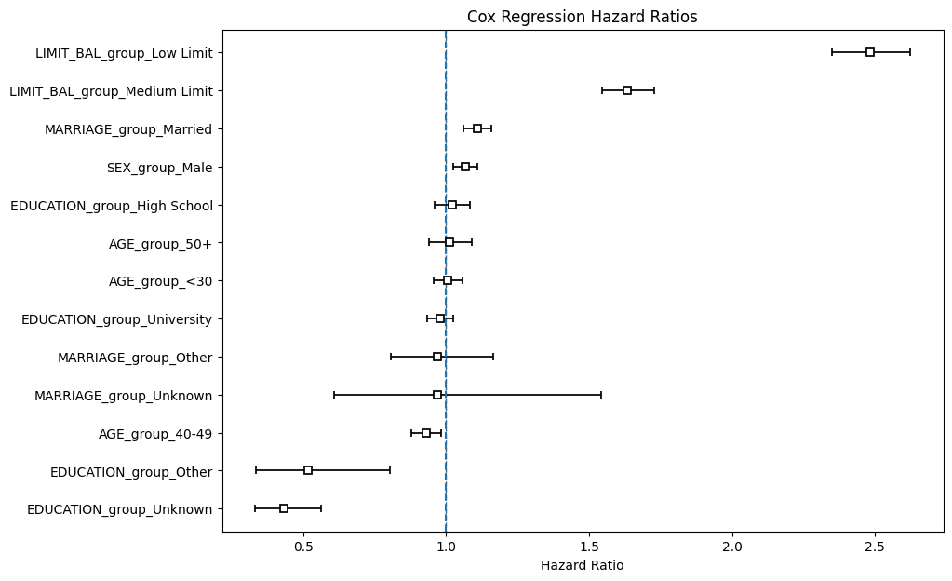
The Cox regression shows that credit limit is the most important predictor of time to first payment delay. Low limit customers have the highest risk, followed by medium limit customers. Male and married customers show slightly higher delay risk, while age and education have weaker effects after adjustment. The hazard ratio plot should show the largest risk increase for Low Limit and Medium Limit groups, making credit limit segmentation especially important for credit card risk management.
- Plot partial effect variables using plot_partial_effects_on_outcome method and identify variable with no significant partial effects compared to baseline and one variable with significant partial effects. Include the screenshot of the plot in the document for these variables.
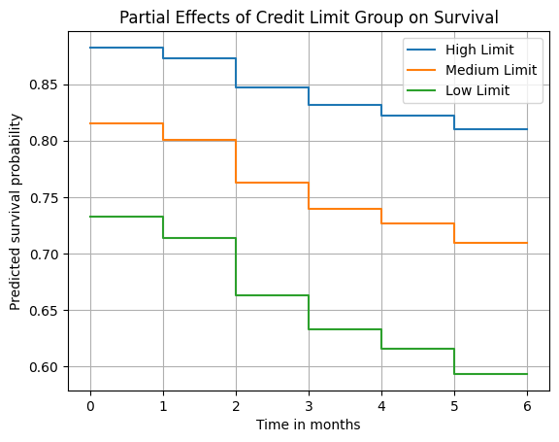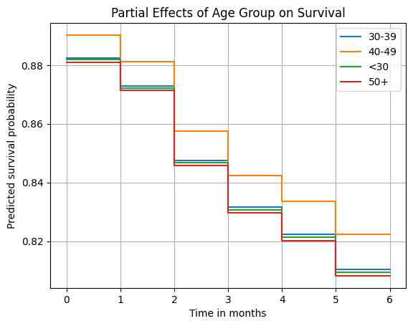
The partial effects plots show how predicted survival changes when selected variables are varied while holding other model variables constant. LIMIT_BAL_group has a strong and significant partial effect. Low Limit customers show the steepest decline in survival probability, indicating the highest risk of first payment delay. In contrast, age groups <30 and 50+ do not show significant partial effects compared with the baseline group 30–39, since their hazard ratios are close to 1 and their p values are above 0.05. Therefore, credit limit group is a significant predictor of time to first delay, while some age categories show little to no adjusted effect.

